Personal Social and Emotional
Self-regulation
-To use feelings stones to express their own feelings.
-To learn about love and who they love and why.
Managing self
-To learn about health and how to take care of their own hygiene.
-To learn about oral health.
Building relationships
-To play as a group to act out different role play.

Communication and Language
Listening and attention and understanding/Speaking
-To talk about different job roles and use new vocab linked to them.
-To listen to others thoughts and feelings.
-To extend their sentences by using ‘because’.
-To retell stories.
-To listen to visitors who come in to talk about job roles.

Literacy/Phonics
Comprehension
-To learn to retell a poems linked to Winter.
-To retell ‘Supertato‘.
-To sequence simple events which happen in stories.
-To begin reading simple sentences.
Word Reading
-To continue to learn Phase 2 sounds and read three lettered/four lettered words.
-To begin reading three worded sentences.
Writing
-To write a range of Phase to sounds.
-To begin labelling with more than one sounds they can hear.

Who are people who help us and what do they do?
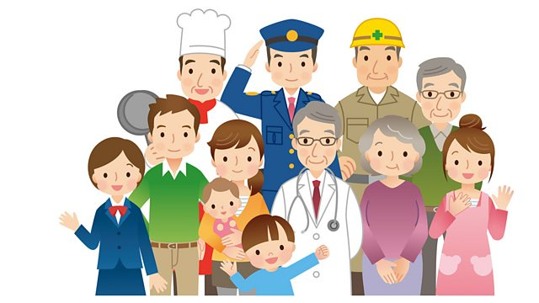
Through this topic the children will learn about a range of different job roles which help people. They will learn about how these job roles help them and others and possibly find interests about these roles. The children will learn about their own health and how to take care of themselves and others.
Maths
Number/Numerical Patterns
-To learn numbers 4, 5 and to learn number bonds to 5.
-To match numbers 0-5 to their value and put in the correct order.
-To subitize numbers 1-5.
-To learn about capacity/weight.

Physical Development
Gross motor skills
-To take part in the BEAM programme to learn ball skills.
- Daily Yoga, Dances.
Fine motor skills
-To practise forming Phase 2 letter shapes.
-To hold pencil more effectively, using pencil grip if needed. (Frog fingers)
-To take part in Finger Gym activities, Dough Disco, Finger Aerobics.

Understanding The World
Past and present
-To talk about job roles in our own families or job roles of grandparents.
People, cultures and communities
--To listen to non-fiction texts about different job roles.
-To learn about Chinese New Year celebrations and Valentines.
The natural world
-To learn about simple maps.
-To learn about the season Winter.
-To begin Forest School sessions.
Expressive Art and Design
Creating with materials
-To add more detail to junk modelling models.
-To explore water colours to draw the environment.
-To learn how to draw portraits of people.
-To use shapes to create pictures.
Being imaginative and expressive
-To act out stories through role play.
-To learn to sing songs about ‘people who help us’.

^{Hooks}
Dress up day ‘What do you want to be when you grow up?’
^{Chinese New Year Workshop}
Visits from different job roles

Key Vocabulary
Chinese New Year
Dragon
Map
Area
Hero
Police
Doctor
Nurse
Paramedic
Dentist
Vet
Firefighter
Teeth
Tools
Uniform
Job/Career
Love
Valentines

