Personal Social and Emotional
Self-regulation
-To learn to use skills learnt about feelings to manage their own.
-To learn the school values.
Managing self
-To learn how to put coats, gloves, hats on independently.
-To learn about the importance of sleep and bedtime.
Building relationships
-To respect others opinions and beliefs.
-To learn to share with others.

Literacy/Phonics
Comprehension
-To learn to retell a poems linked to Autumn.
-To retell ‘The Gingerbread Man’ and ‘The Nativity’.
-To sequence simple events which happen in stories.
Word Reading
-To continue to learn Phase 2 sounds and begin reading CVC words.
Writing
-To write a range of Phase to sounds.
-To begin labelling with initial sounds.
Communication and Language
Listening and attention and understanding
Speaking
-To talk about different events and celebrations they have at home.
-To listen to others discuss their beliefs and thoughts.
-To learn to talk to their partner.
-To learn new vocabulary linked to celebrations.

What are celebrations and why are they special?
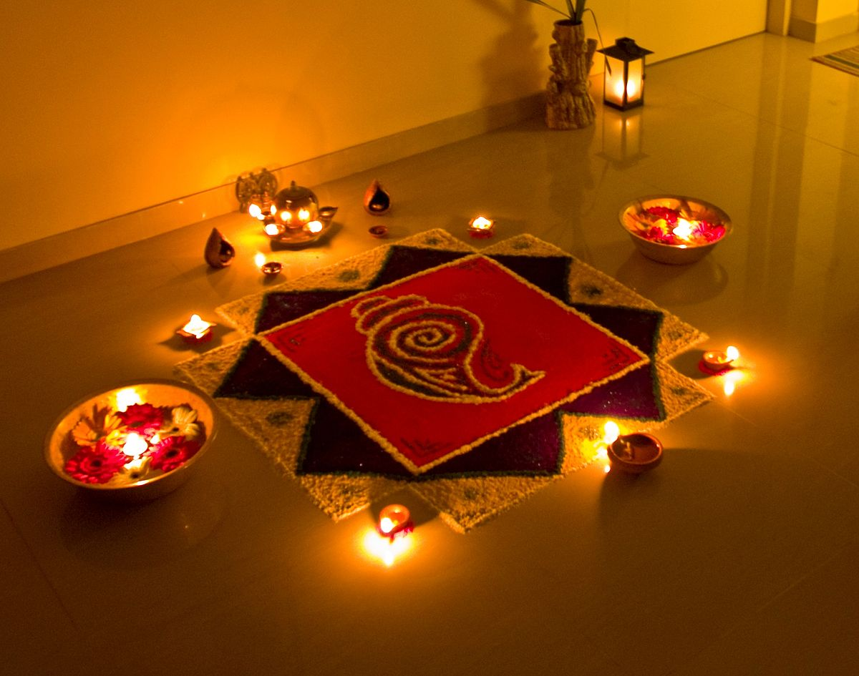
Through this topic the children will learn about a range of celebrations over the months of October, November, December. They will learn about different people and their beliefs.

Maths
Number/Numerical Patterns
-Representing 1, 2, 3.
-Composition and comparing of 1, 2, 3.
-Circles, triangles and positional language.
-To sing counting songs.

Physical Development
Gross motor skills
-To take part in the BEAM programme to move their bodies in different ways.
- Daily Yoga, Dances.
Fine motor skills
-To begin forming Phase 2 letter shapes.
-To learn how to use scissors. To use knives to cut up snack.
-To take part in Finger Gym activities, Dough Disco, Finger Aerobics.

Expressive Art and Design
Creating with materials
-To learn how to use clay to make Diva lamps.
-To learn about transparent art.
-To learn to add features and detail to junk modelling.
Being imaginative and expressive
-To sing nativity songs and perform the show. To learn to match pitch.
-To use small worlds to express knowledge of their own and others stories.

Understanding The World
Past and present
-To learn about old and new toys.
-To talk about traditions at home.
People, cultures and communities
-To learn about Christianity and Hinduism. To name and notice features about people who follow different religions.
The natural world
-To listen to non-fiction texts about Autumn.
-To learn how to cook Gingerbread people.

^{Hooks}
Letters to Father Christmas/Walk to Costa
^{The Nativity}
^{Pantomime}

Key Vocabulary
Celebration
Event
Christianity
Hindu/Hinduism
Religion
Christmas
Diwali
Tradition
Pitch

