Communication and Language
Listening and attention and understanding
Speaking
-To speak and listen in small group, class and one to one discussions, using new vocabulary they have learnt linked to people and emotions.
-To express their emotions and opinions.
-To have conversations with their peers while playing.
Personal Social and Emotional
Self-regulation
-To be able to express their own feelings and begin to understand others feelings.
-To follow simple transitions and routines across the day.
Managing self
-To try a range of new activities with confidence.
-To learn and understand the rules.
Building relationships
-To learn how to share resources with others and take turns.
-To build new relationships with peers and adults.

Physical Development
Gross motor skills
-To move their bodies to express Write Dance stories.
-To learn how to use the Bikes with stabilisers. (Bike License)
Fine motor skills
-To learn how to use crayons, chunky pens, chunky pencils to mark make (Write Dance)
-To take part in Finger Gym activities, Dough Disco, Finger Aerobics.

Expressive Art and Design
Creating with materials
-learning how to use paints and paint tools.
-exploring how to join materials together.
Being imaginative and expressive
-to sing nursery rhymes as a group.
-to learn to retell a poem from poetry basket.
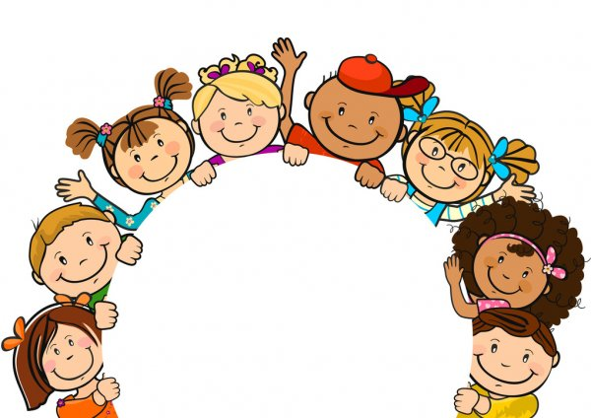
Why is it good to be me?
The children will learn about themselves and others around them, they will learn how to settle into school life by exploring their surroundings.
Literacy/Phonics
Comprehension
-To learn to retell a poem.
-To listen to a range of stories based on feelings and people. Focus texts – Colour Monster/Elmer.
Word Reading
-To begin Phase 2 sounds and orally begin blending.
Writing
-To begin Phase 2 sounds and form them using a range of mark making tools.
-To draw patterns and draw recognisable shapes.
Maths
Number
-To learn numbers 0-5.
-Comparing quantities.
Numerical Patterns
-Practising counting to 10, singing nursery rhymes or playing circle games.
-Sorting objects by colour, size and groups.
-Learning about the day routine (time).
^{Hooks}
Creative workshop – Colour Monster
School tours and meeting new people
All about me shoebox- Show and Tell

Understanding The World
Past and present
-To learn about the adults at school and what their jobs are.
-To talk about similarities/differences between them and their peers.
People, cultures and communities
-To learn about the school environment and discuss Kings Hill.
The natural world
-To learn about seasonal change from summer to autumn. To make observations and drawings. To listen to non-fiction texts related to this.

Key Vocabulary
Feeling
Emotion
People
Human
Respect
Friendship
Phonics/Maths
Learning
Unique
Different

