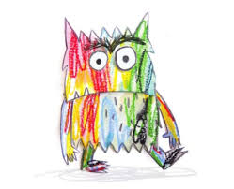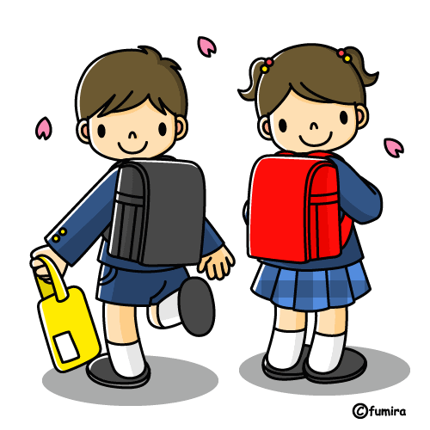

**EYFS Newsletter**

**‘Meet the Teacher’**

Remember to watch our ‘Meet the Teacher’ YouTube video for all the information you need to know about EYFS.



**Term 1**

Welcome to EYFS at The Discovery School! Every term you will receive an EYFS Newsletter to let you know what we are up to.

This term we will be focussing on helping the children to settle into school life and learning all about their emotions and the emotions of others. Our topic is called **‘It’s Good To Be Me’**. Our focus texts this term will be ‘The Colour Monster’, ‘Elmer’ and ‘Rainbow Fish’. Through these texts we will teach the children how to understand their emotions and how to celebrate others similarities and differences.

Phonics

In Phonics this term we are going to focus on **Phase 1** and concentrate on the children’s listening and speaking skills. We will also begin learning **Phase 2** letters and sounds. We will practise how to say the sounds and write the sounds. We will be giving you a parent **Phonic workshop online** soon to explain all about how we teach Phonics. We will also focus on children learning names of others and being about to recognise and practise writing their own.

Maths

In Term 1 we will be focussing on counting and recognising numbers 0-10. We will play lots of circle time games and use practical activities to learn about these numbers. We will also sing lots of well-known counting songs!

We will also be learning about 2D shapes and learning how to say their name and recognise them in the environment.

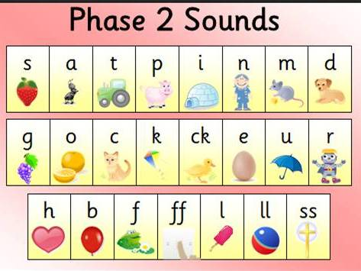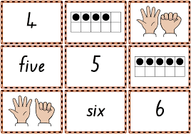

**Key dates to remember…**

* **28th September: the children are in full time drop off is between 8:45 and 9:00 and collection is 3:15 from their allocated zone.**
* **Parents consultations: Monday 12th October, Wednesday 14th October, Monday 19th October or Thursday 22nd October (please book in one 15 minute slot using the parents evening website).**

**Reminders…**

* Please remember to bring in a WATER BOTTLE every day with water inside **NOT** juice or squash.
* Please make sure all your childs uniform is NAMED. If they lose something this make sure they will get it back.
* Please bring in a **family photo** for our home corner displays.
* Please rememeber to bring your child in with **their book bag every day** so we can put any letters or important information inside.
* Please look at **our class page on the website** for any information you need.
* Please write in your yellow reading record when you have read with your child. Please try to read 5 times a week using home readers and Bug Club. BOOKS ARE HANDED OUT MONDAY AND COLLECTED IN FRIDAY FOR QUARANTINE so please make sure the books come back in by Friday.
* **Please ensure if you are providing your child with a packed lunch it includes healthy choices. For more information please go to:** [**https://www.discovery.kent.sch.uk/about-us/school-meals/**](https://www.discovery.kent.sch.uk/about-us/school-meals/)



**Well Done!**

We have been very impressed with how well the children have come in by themselves and settled into the school routine. Well done everyone we appreciate how tricky it can be.