Literacy/Phonics
Comprehension
-To retell stories/poems in correct sequence, draw on language patterns of stories (The Three Little Pigs).
-To suggest how a story might end.
-Give a simple opinion on a book they have read, when prompted.
-Play influenced by experience of books and innovate a well-known story with support.
Word Reading
-Can recognise Phase 2 sounds and most of Phase 3.
-To read books with a range of Phase 2 and 3 CVC words and tricky words. Shows good understanding of what they have read.
-Reads all Phase 2 and some Phase 3 tricky words.
Writing
-Writes most lower case letters correctly.
-Independently writes CVC words to make captions or labels, some beginning to attempt small sentences, using finger spaces between each word.
-To begin writing some upper case letters.
-Spells some tricky words correctly.
Personal Social and Emotional
Self-regulation
-Can make choices and communicate what they need.
-Begin to show persistence when faced with challenges (growth mindset).
-Can reflect on work of others and self-evaluate their own work.
Managing self
-To learn about growth and how to take care of their health through healthy eating and exercise.
-More confident to tackle new challenges and with encouragement will keep going.
Building relationships
-To play by cooperating, listening, speakings and explaining and will listen to advice about how to solve disagreements.
-To work together acting out stories, taking turns to share roles.
-Uses words to solve conflicts.
-Identifies how others feel and responds appropriately.

Communication and Language
Listening and attention and understanding/Speaking
-To use adjectives to describe characters and settings.
-Maintain attention in different contexts and listen well in group work.
-Use talk to help work out problems and organise thinking and explain how things work.
-Asks appropriate questions to find out more and check understanding.
-Uses complex sentences to explain thoughts and ideas.
-Listen to and talk about selected fiction to develop a deep familiarity with new knowledge and vocabulary.
-Begin to connect one idea or action to another using a range of connectives.
-Describe events in some detail.
-Uses talk in different ways, in imaginative play, to develop thinking, to collaborate and plan with others and to express ideas.

What is a fairy tale and how do we become storytellers?
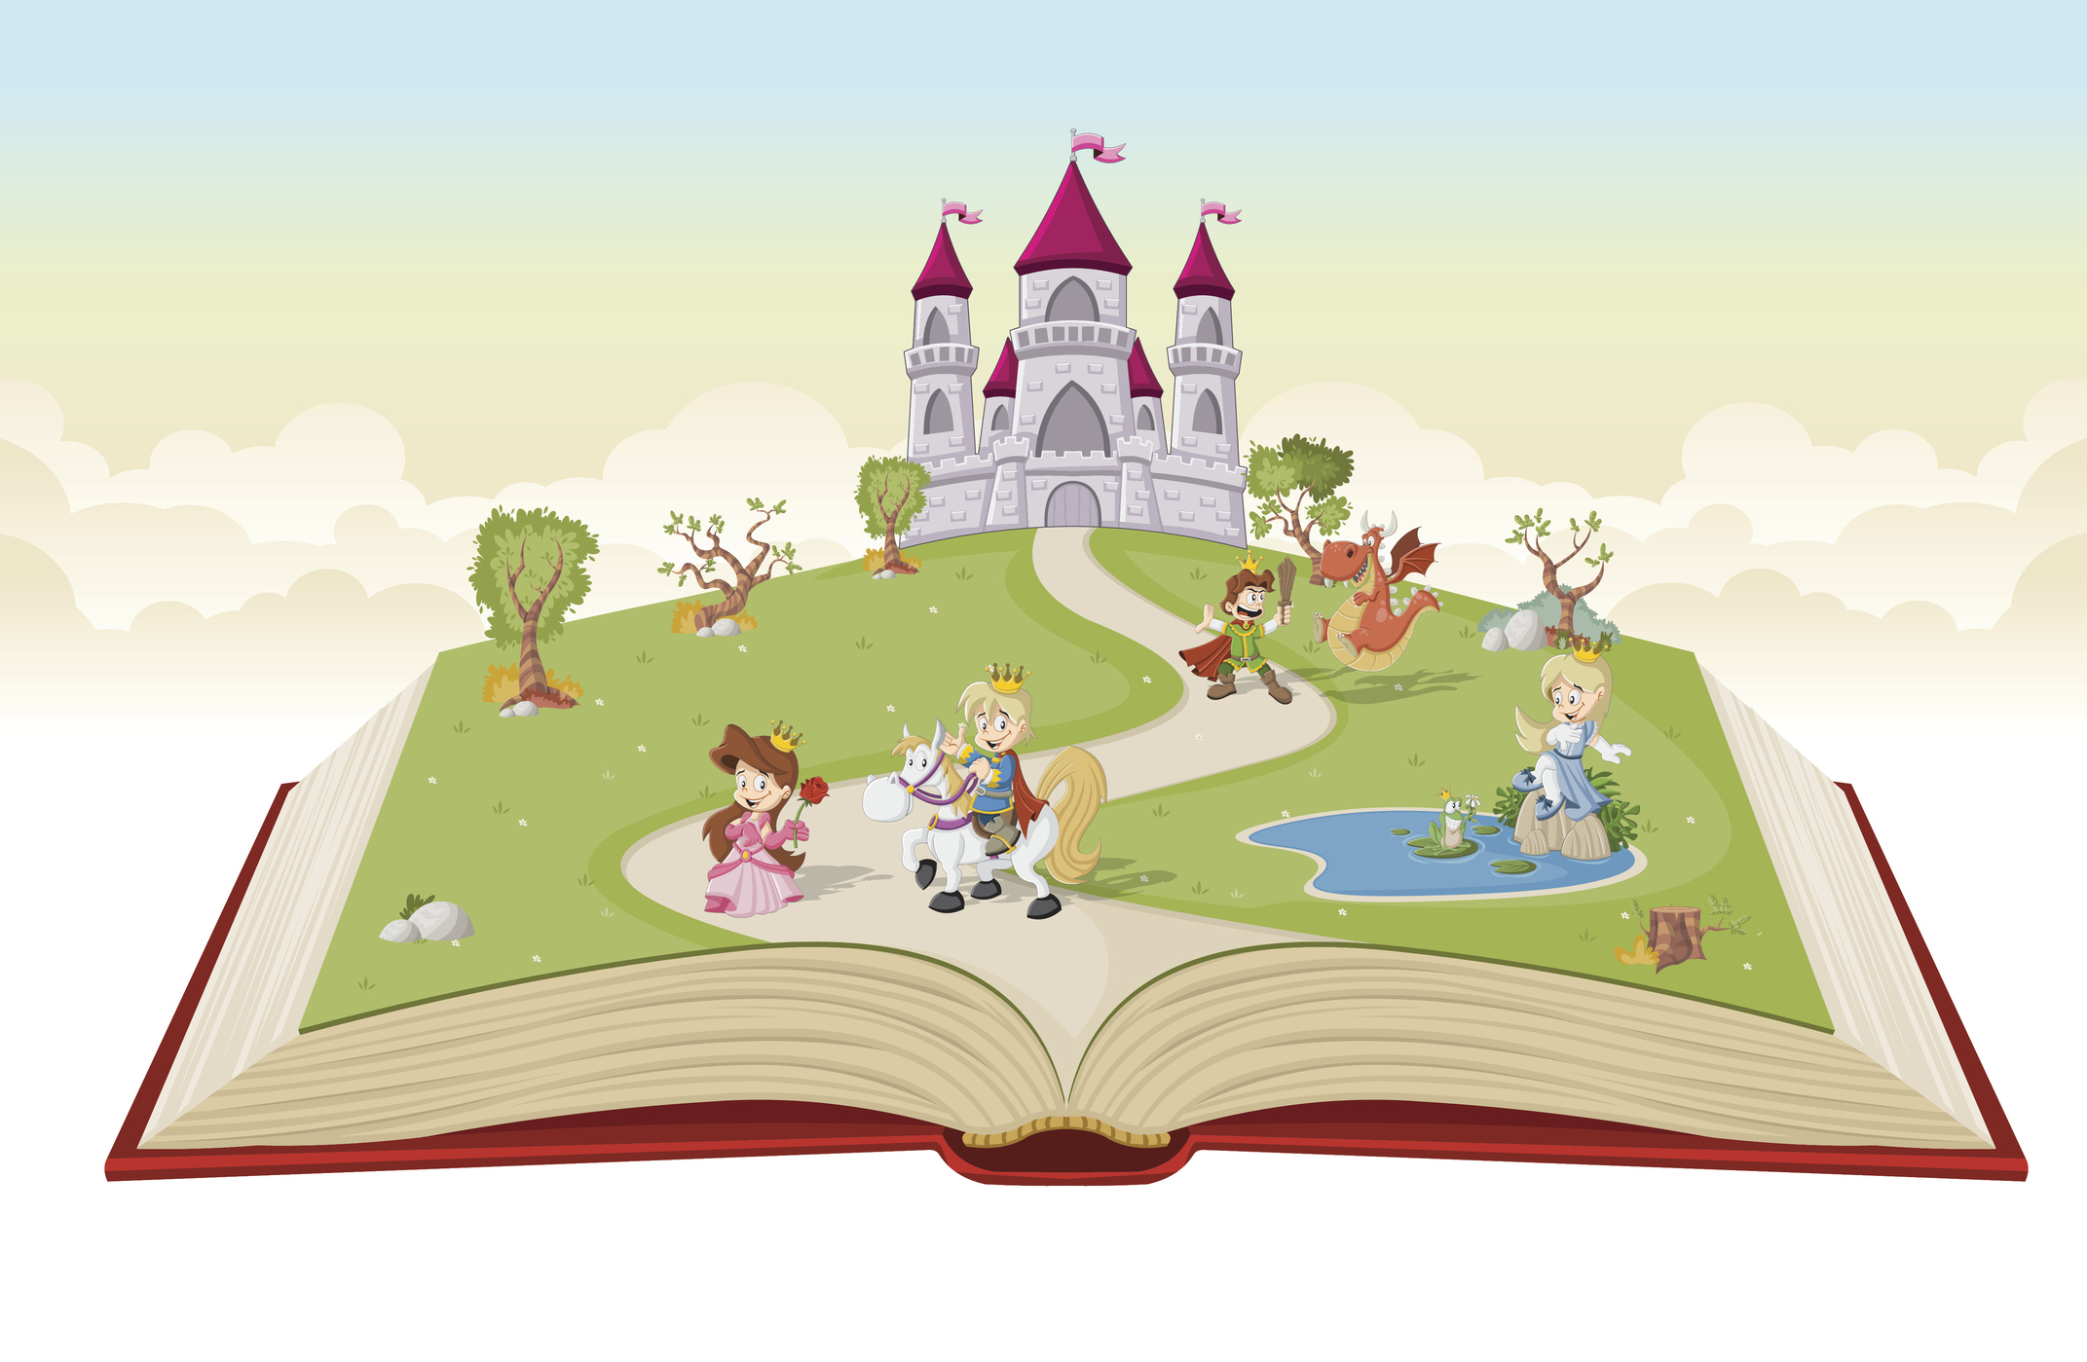
Through this topic, the children will listen to and learn about a range of magical and exciting fairy tales. They will learn about the key features that make a fairy tale and how to become confident and enthusiastic storytellers. The children will act out stories, retell them with actions, draw story maps and make up their own stories. Most importantly, the children will develop a love for the magic of reading and telling stories!

Maths
Number/Numerical Patterns
-To learn numbers 6, 7, 8.
-To learn number bonds for numbers 6, 7, 8.
-To subitise beyond 5.
-To measure length and height using objects. (Jasper’s Beanstalk).
-Explore the composition of numbers 0-8.
-To double numbers and learn to combine two groups for addition.
-To learn about subtraction – using known number bond facts to support.
-To share equally between two groups.

Physical Development
Gross motor skills
-To take part in the BEAM programme to learn further ball skills.
- Daily Yoga, Dances.
-To take part in weekly circuits with a range of different exercises/skills, which involve throwing, kicking, passing a ball, balancing and jumping safely.
Fine motor skills
-To practise forming Phase 2/Phase 3 letters.
-To sit at a table when writing.
-To hold pencil more effectively, using pencil grip if needed. (Frog fingers)
-To take part in Finger Gym activities, Dough Disco, Finger Aerobics.
-To learn how to use woodwork resources.

Expressive Art and Design
Creating with materials
-To learn how to use tools to begin woodwork skills.
- To use different techniques and materials to achieve the desired effect and can talk about what has been created.
- Mixes colours to produce different shades and combines materials to create different textures.
-Use paints to create still life paintings (spring flowers).
-Is beginning to plan a design before starting (construction).
Being imaginative and expressive
- Uses instruments to compose own music.
-Along with others, collects resources to develop own roleplay storylines.
^{Hooks}
World Book Day – Dressing up (3rd March)
^{Pancake Day}
^{Easter Celebrations}

Understanding the World
Past and present
-To talk about themselves as babies – show pictures in ‘Show and Tell’.
-To compare how they look now to then.
People, cultures and communities
--To learn about the story of Easter and Easter celebrations.
-Talks about some features of a Christian Church.
-To learn about Ramadan.
The natural world
-To plant seeds and learn about what they need to grow.
--To talk about human growth.
-To learn about the season Spring.
-To look at, and makes maps, of local environment.

Key Vocabulary

Story structure – beginning/ending
Fairy tale
Character/setting/problem/solution
Event
Adjective
Sentence
Spring
Easter
Christianity
Daffodil
Growth
Plant
Length
Height
Evil
Imagination
Conflict
Resolution
Morals

