Communication and Language
Listening, attention and understanding/Speaking
-To be able to articulate their ideas and thoughts in well-formed sentences.

-To be able to connect one idea or action to another using a range of connectives.

-To be able to engage in non-fiction books.
Books about people who help us/seasonal changes into Winter/Chinese New Year celebrations.

-To be able to listen to and talk about selected nonfiction to develop a deep familiarity with new knowledge and vocabulary regarding different places around the world.

-To be able to express their ideas and feelings about their experiences using full sentences, including use of past, present and future tenses and making use of conjunctions, with modelling and support from their teacher.

-To listen to information about different job roles and talk about things they remember and things they like or do not like about them. Visitor workshops

Literacy/Phonics
Comprehension
- To be able to demonstrate understanding of what has been read to them.
-To retell the story ‘Supertato’ through Talk for Writing.
-To create their own stories through Tales Toolkit which include language and vocabulary they have learnt from stories read in class.
Word Reading
-To knows the sounds for each letter in the alphabet and at least five digraphs.
-To be able to read and write some CVCC words.
-To know and be able to read a range of tricky words matched to FFT Phonics Scheme.
-To be able to read words and simple sentences consistent with their phonic knowledge.

Writing
-To be able to write recognisable letters, most of which are correctly formed.
-To be able to segment and spell words when writing independently.
-To be able to independently write CVC words and use their phonetic knowledge to start having a go at labelling their work and creating small sentences.
-To begin to be able to draw and innovate story maps from well-known stories.

Personal Social and Emotional
Self-regulation
- To be able to show resilience and perseverance in the face of challenge.
Growth Mindset
-To be able to Identify and moderate their own feelings socially and emotionally.
-To learn about Valentine’s Day and celebrate who they love and why.

Managing self
- To be able to display confidence to try new activities
- To be able to Manage own basic hygiene and personal needs.
-To learn about oral health and the importance of brushing your teeth.
-To learn about fruit/vegetables and making healthy choices to keep themselves fit and healthy. To know good practices regarding health and wellbeing such as eating healthily, exercising regularly, sleep and reasonable amounts of screen time.

Building relationships
-To know what democracy means and begin to build an awareness of majority votes through voting in class.
Book votes/Story votes
-To share roles and compromise when acting out stories through roleplay.

Who are people who help us and what do they do?
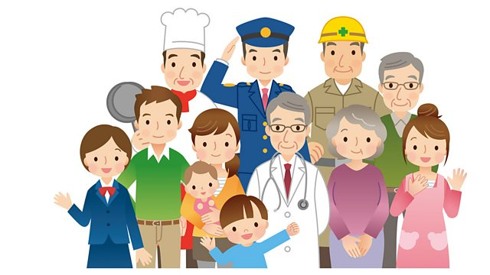
Through this topic the children will learn about a range of different job roles which help people. They will learn about how these job roles help them and others and possibly find interests about these roles. The children will learn about their own health and how to take care of themselves and others.

Maths - Number/Numerical Patterns
-To learn numbers 5, 6, 7, 8. To learn their value and composition.
-To subitise to 5 through number sense games.
-To understand what equal means and compare amounts.
-To be able to match amounts and compare using mathematical language (counters, dice, Numicon, dominoes, fingers, money numerals, irregular arrangements)
-To be able to order numbers and say what is one more or one less.
-To be able to count with one-to-one correspondence. To be able to count forwards and backwards on a number line understanding one more and one less.
-To learn how to add and subtract using objects and learn the symbols such as ‘+’ ‘-‘ ‘=’.
-To learn about measures of capacity.
-To learn about equal/unequal amounts and making comparisons.

Physical Development
Gross motor skills
- Daily Yoga, Dances.
- To be able to develop the overall body strength, co-ordination, balance, and agility needed to engage successfully with future physical education sessions and other physical disciplines including dance, gymnastics, sport,
-To be able to perform a single skills or movement with simple control.
-To sit at tables when writing to develop their core muscle strength and support posture.

Fine motor skills
-Dough Disco/Finger Aerobics
-To continue to develop pencil control to create handwriting which is quicker and clear.
-To continue to use scissors and small tools, safely and confidentially. For children to know which scissors and pencils suit their skills, to support them in using them correctly and moving onto new resources once, they are ready.

Expressive Art and Design - Creating with materials
-To be able to return to and build on their previous learning, refining ideas and developing their ability to represent them.
-To know that different materials can be used to create Art.
- To be able to explore art from different places around the world.
-To be able to use simple tools and techniques competently and appropriately.
-To be able to selects tools and techniques needed to shape, assemble and join materials they are using and explain the processes they have used.
Being imaginative and expressive
-To be able to participate in action songs which call for movement
-To be able to move to musical stimuli in a variety of ways, e.g. hopping, marching, skipping, and jumping.
-To take part in the Chinese New Year workshop, learning how to ribbon dance and lion dance with costume.
-To act out ‘people who help us’ themed stories through role play.
Understanding the World
Past and present
- To be able to recognise some similarities and differences between life in this country and life in other countries.
- To be able to compare characters from stories, including figures from the past.
People, cultures and communities
-To learn about different cultures in other places in the world. China
-To learn about different job roles in the community and their importance to the world.
The natural world
-To learn about the seasonal change into Winter.
-Forest school sessions in Discovery Walk.
-To be able to compare the natural world in different places around the world. Looking at geographical and climate differences.
-To be able to make observations and draw pictures of animals and plants.
-To plant seeds and grow healthy natural food.

^{Hooks}
^{Visitors}
^{Chinese New Year Workshop}

Key Vocabulary
People
Community
Job/s
Help
Support
Non-Fiction
Information
Chinese New Year
Dragon
Lunar
Growth Mindset
Perseverance
Winter
New Year
Freezing
Firefighter
Dentist
Police Officer
Vet
Optician
Paramedic
Nurse
Doctor
Equipment/Tools
Hero

