Special Educational Needs and Disabilities (SEND) Information Report

The Discovery School



Inclusion Team

SEND Governor:
Annabel Cornall
Louise Connelly
Leanne Edwards

SENCO
Vicenta Fresneda Alcala
Contact No. 01732847000

Inclusion Team:
sendteam@discovery.kent.sch.uk

Approved by: SEND Governors |  | Date: 19/11/2025
Last reviewed on: | November 2025
Next review due by: | November 2026

Contents
1. What types of SEND does the school provide for? 4
2. Which staff will support my child? 5
3. What should I do if I think my child has SEND? 7
4. What happens if the school identifies a need? 8
5. How will the school measure my child’s progress? 9
6. How will I be involved in decisions made about my child’s education? 10
7. How will my child be involved in decisions made about their education? 11
8. How will the school adapt its teaching for my child? 132
9. How will the school evaluate whether the support in place is helping my child? 163
10. How will the school ensure my child has appropriate resources? 173
11. How will the school make sure my child is included in activities alongside pupils who don’t have SEND? 174
12. How does the school make sure the admissions process is fair for pupils with SEN or a disability? 185
13. How does the school support pupils with disabilities? 195
14. How will the school support my child’s mental health and emotional and social development? 206
15. What support is in place for looked-after and previously looked-after children with SEN? 226
16. What support will be available for my child as they transition between classes or settings or in preparing for adulthood? 17
17. What support is available for me and my family? (Local Offer) 248
18. What should I do if I have a complaint about my child’s SEND support? 19
19. Supporting Documents…………………………………………………………………………………………………………….19
20. Glossary 20

Dear parents and carers,
The aim of this Information Report is to explain how we implement our SEND policy. In other words, we want to show you how SEND support works in our school.
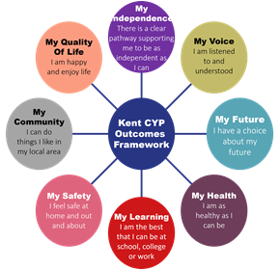
As educational professionals, we are all working towards the ultimate goal of growing independent young people as they prepare for adulthood. All provision and support we provide is working towards achieving the Kent Children and Young People (CYP) Outcomes Framework:

If you want to know more about our arrangements for SEND, read our SEND policy alongside this Information Report.
You can find our SEND policy on our website
Note: If there are any terms we’ve used in this information report that you’re unsure of, you can look them up in the Glossary at the end of the report.

1. What types of SEND does the school provide for?
Our school provides for pupils with the following needs (as outlined in the SEND Code of Practice 2015):

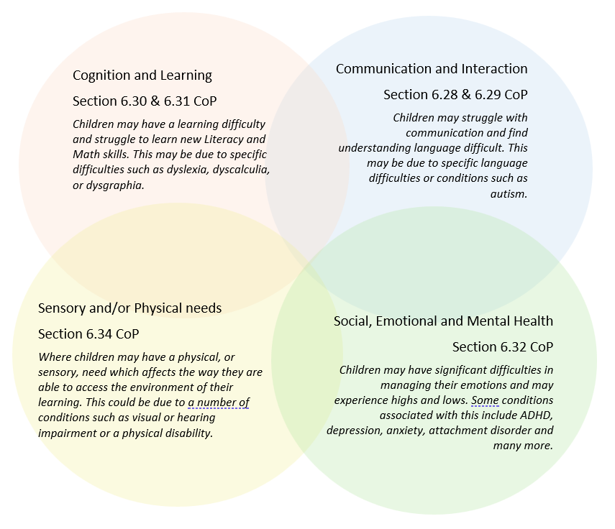

Often you will find that children’s needs overlap and are rarely confined to one area of need, which is why it is important to gain a wholistic overview of your child.
More information about the Areas of Need can be found in the Special educational needs and disability code of practice: 0 to 25 years (link below).
SEND_Code_of_Practice_January_2015.pdf (publishing.service.gov.uk)


2. Which staff will support my child, and what are their key responsibilities?

At The Discovery School all staff are considered responsible for supporting the needs of pupils with SEND. Our staff are committed to regular, high-quality training to ensure that they have the knowledge and skills to better meet a wide range of pupil needs.
Below outlines key staff who may be supporting your child. Please note that this list is not exhaustive.
Miss Tina Gobell – Headteacher and qualified SENCo (She achieved the National Award in Special Educational Needs Co-ordination in October 2012).
Mrs Sarah Boyd – Pupil Support Worker
Miss Emma Randle – Lunchtime Pupil Support Worker
Sam – Our Therapy dog

Our Special Educational Needs Co-ordinator, or SENCO

Mrs Vicenta Fresneda Alcala – SENCo
Our lead SENCO is Vicenta Fresneda Alcala
She has 7 years’ experience in this role and has worked as qualified teacher in different Key Stages including Secondary School and providing specialist support. She is a qualified teacher.
She achieved the National Award in Special Educational Needs Co-ordination in October 2018. She has had update training in regards to how to meet the children needs.
Our current Chair of Governors as well as our named SEND Governor, Annabel Cornall, is an experienced SENCo, Teacher and Senior Leader.

Class/subject teachers
All of our teachers receive in-house SEN training, and are supported by the SENCo to meet the needs of pupils who have SEND.
Staff have attended different training in relation to each area of need the training is provided in-house or by external Agencies. The list of our training includes:
SEND Processes & specific training
- Provision Mapping
- Adaptive Teaching
- Alternative ways of recording.
- Training linked to specific neurodiversity conditions e.g ADHD, ASD, DLD.
Communication and Interaction
- Autism Enterprise Trust
- Language/Speech Link
- Widget Training The use of Visuals in the classroom
Cognition and Learning
- Precision Teaching
- Rosenshine Principles and adaptive teaching
- The use of Metacognition in the classroom
- Adaptive Teaching and computing
- Spelling
- The EYFS Curriculum and Adaptive teaching
- The Science of Learning
- Toe-by-Toe
Social, Emotional and Mental Health
- Adverse childhood experiences (ACES)
- Trauma informed Practice.
- Specific training
- Grief & Loss Training
- Drawing and Talking
- Pro-Act Scipr
Sensory and/ or Physical
- Diabetes training
- Sensory Circuits/ Sensory Processing
- BEAM

Teaching assistants (TAs)
We have a great team of 32 TAs, including 5 higher-level teaching assistants (HLTAs) who are trained to deliver SEND provision.
We have teaching assistants who have been trained to deliver different interventions. In the last academic year, TAs have been trained to deliver interventions such as:
Language Link/ Speech Link, Black Sheep interventions, First class number, Phonics, handwriting, pre-teaching, social skills, FFT reading, Sensory Circuits. Please find more details about specific interventions on section 8.

External agencies
Sometimes we need extra help to offer our pupils the support that they need. Whenever necessary we will work with external support services to meet the needs of our pupils with SEND and to support their families. These may include:
- NHS services – including the School Nursing Service and Community Paediatrics
- Early Help Service, including organisations like Salus
- Consultations with specialist teachers and speech and language therapists through STLS / SALT surgeries
- Information and Advice Service Kent (IASK)
- Link to Disabled Children’s Service for support to families for some pupils with high needs

- Child and adolescent mental health services (CAMHS)
- Education welfare officers
- Educational psychologists

- GPs or paediatricians
- NELFT practitioners
- Occupational therapists
- Therapeutic practitioners

- Safeguarding services
- School nurses
- SEND Inclusion Advisor
- Specialist Teacher Service
- Speech and language therapists

- Voluntary sector organisation

3. What should I do if I think my child has SEND?
If you think your child might have SEND, raise your concern with the school so that the SENCO is aware.
Phase 1 | The SENCo may utilise some further, in-depth assessments to establish the needs of the child. These may include toolslike: Test of Auditory Processing Skills (TAPS), Dyslexia Screening, Dyslexia Portfolio, Phonological Processing assessments (PHaB), Test of Visual Processing Skills (TVPS), Cognitive Ability Tests (CATs), Sensory Profile, Gross Motor Skills assessments (BEAM), Speech Link Assessment, Language Link Assessment, Language for Learning observation, Renfrew Action Picture Test, Leuven Scales, Boxall Profile, Strengths and Difficulties Questionnaire (SDQ). These formal assessments may be supported by in class observations of the child.
Phase 2 | We will meet with you to discuss your concerns and try to get a better understanding of what your child’s strengths and difficulties are. Together we will decide what outcomes to seek for your child and agree on next steps. We will make a note of what’s been discussed and add this to your child’s record.
Phase 3 | We will implement the agreed strategies and monitor these over an agreed period of time. These are likely to be universal strategies set out in the mainstream core standards. A copy of this can be found here: https://www.kelsi.org.uk/__data/assets/pdf_file/0005/117257/Special-educational-needs-mainstream-core-standards-guide-for-parents.pdf . This will initiate the ‘Graduated Approach’ where support will be continually reviewed. See next page for more details.
Phase 4 | If we decide that your child needs SEND support, we will formally notify you and your child will be added to the school’s SEND register. They will receive additional support and this will be reviewed using the assess, plan, do, review model.

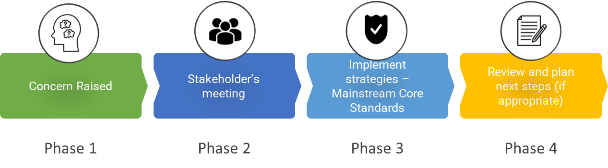

4. What happens if the school identifies a need?
Once assessments have been completed and needs agreed the SENCo and Class Teacher will draw up a provision plan that sets out all of the support that the child will be receiving.

When establishing the provision plan, the school will seek the input of the child and their parents. Provision plans are shared with parents so they can be clear about the support that is in place for the child.

The provision plan will detail two waves of support:

- Personalised strategies—the things that will be done to adjust the curriculum and teaching environment to ensure that the child makes good progress.

- Targeted interventions—small group or individualised support outside of the curriculum that addresses the child’s SEND The same process is followed if a concern is raised by the school.
All our class teachers are responsible for the monitoring of all pupils who have been identified as having SEND. They also review those who are not making the expected level of progress in their schoolwork or socially.

- Teachers use a range of class-based techniques to assess pupils progress and identify any potential SEND. These include: continuous assessment through-out lessons, assessing pupil knowledge retention through retrieval practice, teacher assessment against the National Curriculum expectations, phonics assessments and screenings, termly formative assessments, standardised tests such as reading age tests or NFER assessments, end of year summative assessments and continuous teacher/TA observation.

They also draw on their training and expertise of child development to assess pupils progress against the wider curriculum as well as considering pupils’ physical and social-emotional development.
Pupils who don’t have SEND usually make progress quickly once the gap in their learning has been filled.
If the pupil is still finding it difficult to make the expected progress, the teacher will talk to the SENCO, and will contact you to discuss the possibility that your child has SEND, and the school will follow the graduated approach (see previous page).

5. How will the school measure my child’s progress?
The provision in place for each pupil with SEND is reviewed regularly in school—the frequency of which may vary depending on the needs of the child however, parents should expect at least three reviews per year—one at each parents’ evening and one at the end of the academic year that incorporates the child’s new teaching team.
Each review of the SEN provision plan will be informed by the views of the pupil, parents and class/subject teachers and the assessment information from teachers which will show whether adequate progress towards targets We will follow the ‘graduated approach’ to meeting your child’s SEND needs. The graduated approach is a 4-part cycle of assess, plan, do, review.
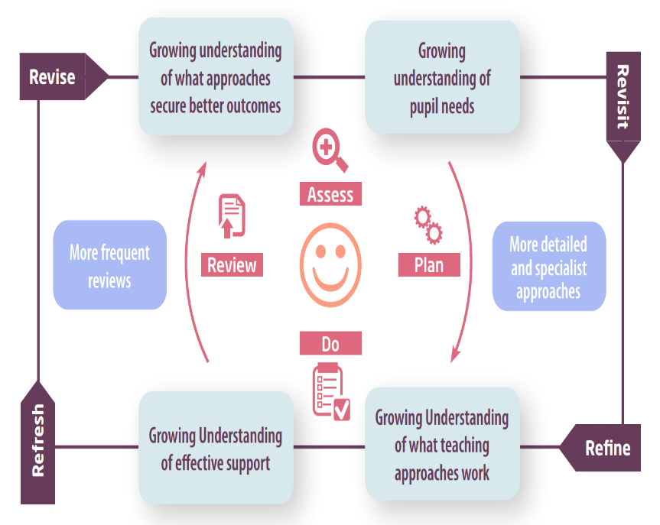

Assess | If your child is not making the expected level of progress, we will make an assessment to find out what strengths and difficulties your child has. We will ask for you and your child’s input, as well as getting help from external professionals where necessary.
Plan | In discussion with you and your child, we will decide what outcomes we are hoping to achieve. We will make a plan of the support we will offer your child to help them meet those outcomes. We will make a record of this and share it with you and all relevant school staff.
Do | We will put our plan into practice.  The class teacher, with the support of the SENCO, will be responsible for working with your child on a daily basis, and making sure the support we put in place is having the impact we intended.
Review | We will assess how well the support we put in place helped the pupil to meet the outcomes we set. We will use our improved understanding of your child’s needs to improve the support we offer; this may mean the Plan, Assess, Do, Review cycle continues.

6. How will I be involved in decisions made about my child’s education?
We will provide annual reports on your child's progress.
A member of staff who knows your child well will meet 3 times a year, to:
- Set clear outcomes for your child’s progress
- Review progress towards those outcomes
- Discuss the support we will put in place to help your child make that progress
- Identify what we will do, what we will ask you to do, and what we will ask your child to do
The SENCo may also attend these meetings to provide extra support.
We know that you’re the expert when it comes to your child’s needs and aspirations. So, we want to make sure you have a full understanding of how we’re trying to meet your child’s needs, so that you can provide insight into what you think would work best for your child.
We also want to hear from you as much as possible so that we can build a better picture of how the SEND support we are providing is impacting your child outside of school.
If your child’s needs or aspirations change at any time, please let us know right away so we can keep our provision as relevant as possible.
If you have concerns that arise between these meetings, please contact:
Member of staff | Contacted regarding...
Key Worker (where appropriate) | Day to day questions about your child
Class Teacher | Day to day questions about your child (where they do not have a key worker)  Your child’s in class support provision  Your child’s achievements and progress  Provision reviews
SENCo (Special Educational Needs Co-ordinator)  Mrs Vicenta Fresneda Alcala  senco@discovery.kent.sch.uk | Identification of needs  Co-ordinating visits from outside professionals  Reports and diagnoses made by outside professionals  Specific support, guidance and direction for parents for individual needs  Statutory assessment, where appropriate  High needs funding applications, where appropriate  Access arrangements for external assessments (SATS, 11+ etc)  Assessments made of your child  Referrals made to outside agencies, where appropriate  Clarification of SEND processes

7. How will my child be involved in decisions made about their education?

The level of involvement will depend on your child’s age and individual needs. We recognise that no two pupils are the same, so we will decide on a case-by-case basis, with your input.

We may seek your child’s views by asking them to:
- Attend meetings to discuss their progress and outcomes
- Prepare a presentation, written statement, video, drawing, etc.
- Discuss their views with a member of staff who can act as a representative during the meeting
- Complete a survey


8. How will the school adapt its teaching for my child?

The Discovery School adapts teaching for all learners by anticipating and responding to children’s individual needs. Adjustments are made to the delivery of the curriculum, where necessary, in order to help all pupils, achieve. High-quality teaching is our first step in responding to your child’s needs, per the SEN Code of Practice (2015, 6.37):

High quality teaching, differentiated for individual pupils, is the first step in responding to pupils who have or may have SEN. Additional intervention and support cannot compensate for a lack of good quality teaching. Schools should regularly and carefully review the quality of teaching for all pupils, including those at risk of underachievement. This includes reviewing and, where necessary, improving, teachers’ understanding of strategies to identify and support vulnerable pupils and their knowledge of the SEN most frequently encountered.

We will make sure that your child has access to a broad and balanced curriculum in every year they are at our school. We will adapt our approaches to how we teach to suit the way the pupil works best. There is no 'one size fits all’ approach to adapting the curriculum, we work on a case-by case basis to make sure the adaptations we make are meaningful to your child and are guided by the Mainstream Core Standards in the first instance.
We have constant training in line with Adapted Teaching and all our teachers as well as teaching assistants have access to this training.

These adaptations may include:

  - Adapting our approaches, for example, giving longer processing times, pre-teaching of key vocabulary, reading instructions aloud, etc.

  - Adapting our resources and staffing


  - Using recommended aids, such as laptops, coloured overlays, visual timetables, larger font, etc.

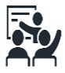
  - Teaching assistants or support staff will support pupils appropriately depending on their presentation of need

  - Scaffolding lesson material

See below our Waves of Support as a robust example of our practice:

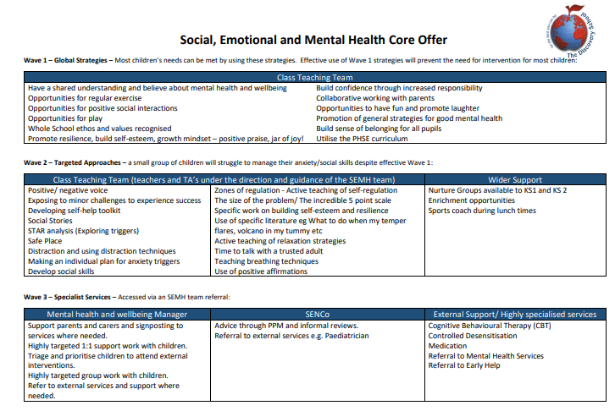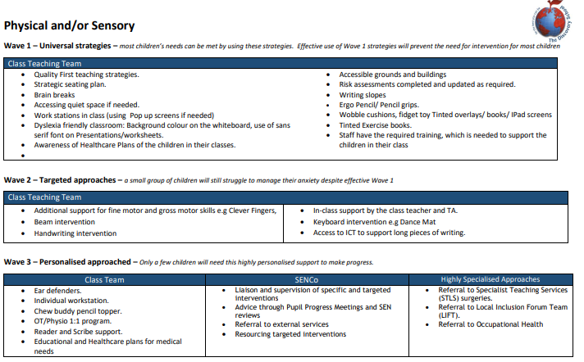
We may also provide the following interventions:
- Daily reading
- Precision Phonics daily
- Pre - teaching
- Barrier games
- Colourful semantics
- Word Aware
- Speech and language link intervention
- Black Sheep press targeted interventions
- Handwriting intervention
- FFT Phonics
- Semantic Links
- Read Write Inc
- 1st Class Maths
- Talkabout
- Language for Thinking
- Social skills groups e.g., Circle of Friends
- Sensory Circuits
- BEAM
- Zones of Regulation
These interventions are part of our contribution to Kent County Council’s local offer

9. How will the school evaluate whether the support in place is helping my child?
We use a range of class-based techniques to assess pupils progress and identify any potential SEND. These include: continuous assessment throughout lessons, assessing pupil knowledge retention through retrieval practice, teacher assessment against the National Curriculum expectations, phonics assessments and screenings, termly formative assessments, standardised tests such as reading age tests or NFER assessments, end of year summative assessments and continuous teacher/TA observation.
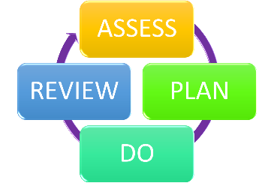
We will evaluate the effectiveness of provision for your child by:
- Reviewing their progress towards their goals each term
- Reviewing the impact of interventions after 12 weeks
- Using pupil questionnaires
- Monitoring by the SENCo
- Using provision maps to measure progress
- Holding an annual review (if they have an education, health and care (EHC) plan.

10. How will the school ensure my child has appropriate resources?
It may be that your child’s needs mean we need to provide additional resources such as:
- Additional resources to support their learning
- Adaptations to support provided in class
- Further training for our staff
- External specialist expertise
Where appropriate, we will consult with external agencies to get recommendations on what will best help your child access their learning and use our best endeavours to ensure these are supplied.

11. How will the school make sure my child is included in activities alongside pupils who don’t have SEND?


The expectation is that all schools providing an inclusive provision for all pupils. It may be necessary for some pupils to receive interventions in addition to a broad and balanced curriculum.
- All of our extra-curricular activities and school visits are available to all our pupils, including our before and after-school clubs.
- All pupils are encouraged to go on our school trips, including our Year 6 residential trip.
- All pupils are encouraged to take part in Sports Days.
- No pupil is ever excluded from taking part in these activities because of their SEN or disability and we will make whatever reasonable adjustments are needed to make sure that they can be included.

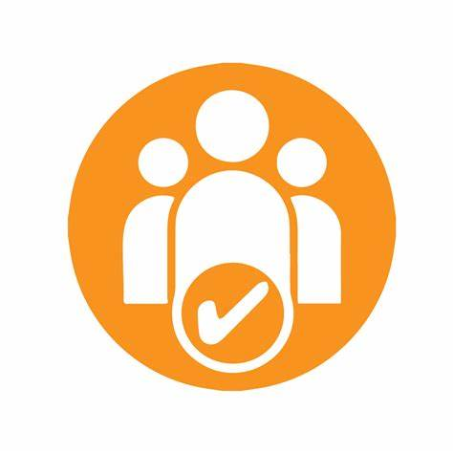
12. How does the school make sure the admissions process is fair for pupils with SEN or a disability?

12.a The Discovery School is a community school and as such our admissions policy is set by Kent County Council in order with the local authority’s Co-ordinated Scheme for Primary Admissions.
The school’s published admission number (PAN) is 90
The Discovery School has one intake per year Application Procedure and follows the procedures, timetable and deadlines set by Kent County Council.
Parents will have the opportunity to visit the school; we will contact people who have registered an interest in The Discovery School. An RCAF (Reception Common Application Form) has to be completed at the appropriate time, online, and returned to Kent County Council.
Kent County Council allocate places based on the criteria for Community and Voluntary Controlled Schools:
- Children in Local Authority Care
- Current Family Association (sibling)
- Health and Special Access Reasons; including those children with ad Education and Health Care Plan. Health & Special Access Reasons Medical, health, social and special access reasons will be applied in accordance with the school’s legal obligations, in particular those under the Equality Act 2010.
Priority will be given to those children whose mental or physical impairment means they have a demonstrable and significant need to attend a particular school. Equally, this priority will apply to children whose parents/guardians physical or mental health or social needs means that they have a demonstrable and significant need to attend a particular school. Such claims will need to be supported by written evidence from a suitably qualified medical or other practitioner which can demonstrate a special connection between these needs and the particular school that parents feel is the only school that can accommodate these needs
- Nearness of Children’s Home to School Oversubscription Criteria Where the number of applicants exceeds 90 for a new intake, the following criteria will be applied. Before the application of oversubscription criteria children with a bold statement of special educational need which names the school will be admitted.
12.b Admission Arrangements for Reception Year (EYFS)
At The Discovery School children have the opportunity to have nine full terms in the Foundation Stage and KS1.
We admit all children in the September after their fourth birthday following allocation of a school place, please see 12.a. In order that all pupils and parents feel confident and comfortable within our school surroundings we invite all preschoolers to visit our school for settling in sessions before they start in September. This initiative allows both parents and pupils to build up their friendship networks, as well as meet their class teacher, other staff and familiarise themselves with their classroom, our school building and school routines.
Admission for Year Groups other than Reception In-Year Casual Admissions are admissions which take place outside of the normal entry to school. An IYCAF (in year common application form) needs to be completed and returned to the school for process. If a place is not available a refusal letter and a request for going onto the waiting list will be sent out. IYCAF forms are available from the school or online at www.kent.gov.uk, https://www.kent.gov.uk/education-and-children/schools/school-places
The Discovery School is an outstanding and therefore a very popular school. If it has not been possible for you to be offered a place at The Discovery School, you may have the right to appeal against this decision to an Independent Appeal Panel.
For more details, please visit our Admissions Policy.

13. How does the school support pupils with disabilities?


You’re disabled under the Equality Act 2010 if you have a physical or mental impairment that has a ‘substantial’ and ‘long-term’ negative effect on your ability to do normal daily activities.
The Discovery School intends, over time, to increase the accessibility of our school for disabled pupils. The Discovery School is committed to providing an environment that enables full curriculum access that values and includes all pupils, staff, parents and visitors regardless of their education, physical, sensory, social, spiritual, emotional and cultural needs. Definition of Disability, The Disability Discrimination act (DDA) defines a disabled person as someone who has: “A physical or mental impairment which has a substantial and long-term adverse effect on his or her ability to carry out normal day-to-day activities”
• “Physical impairment” includes sensory impairment.
• “Mental impairment” includes learning difficulties and an impairment resulting from or consisting of a mental illness.
• “Substantial” means more than minor or trivial.
• “Long term” is defined as 12 months or more.
• This definition includes a wide range of impairments such as dyslexia, autism, speech & language impairments and attention deficit hyperactive disorder. These will only be defined as a disability if the effect on the child’s ability to carry out day to day activities is substantial and long term, as defined above.

Under the Equality Act 2010 all schools must have an Accessibility Plan. The Equality Act 2010 replaced all existing equality legislation including the DDA. The effect of the laws is the same as in the past, meaning that ‘Schools cannot lawfully discriminate against pupils because of sex, race, disability, religion or belief and sexual orientation’.
Our Accessibility Plan sets out objectives of our school in increasing access to education for disabled pupils in the three areas, as required by the planning duties in the DDA:
a) Increasing the extent to which disabled pupils can participate in the school curriculum; which includes teaching and learning and the wider curriculum of the school, such as participation in after school clubs, leisure and cultural activities or school visits;
b) Improving the environment of the school to increase the extent to which disabled pupils can take advantage of education and associated services; c) Improving the delivery to disabled pupils of information, which is provided in writing for pupils who are not disabled.

See our Accessibility Policy for more information

14. How will the school support my child’s mental health and emotional and social development?

At The Discovery School, we highly value the importance of developing and sustaining good mental health and wellbeing of all our pupils, including those with SEND.

Our school values and inclusive ethos underpin everything we do in developing our children’s emotional and social skills. Our taught curriculum actively addresses mental health and teaches children how good mental health can be maintained and how they can seek help when they are worried about their wellbeing. It also educates all children about a range of special educational needs so that they can be informed and empathetic citizens, celebrating diversity and uniqueness.
In addition, we actively seek the views of children with SEND and consider their wellbeing through our pupil passports and provision reviews. These proactive steps mean that incidences of discrimination or bullying with regard to SEND are virtually non– existent.

Our SEMH team meets consistently once a month, to identify and plan support for pupils and families in need. Our SEMH team includes staff with enhanced training.
Our SEMH team members are:
- Miss Tina Gobell – Headteacher & DSL
- Mrs Jennifer Oakes – Deputy Head teacher & DSL
- Dr Jane Wilce-Cordner – Senior Assistant Headteacher & DSL
- Mrs Vicenta Fresneda Alcala – SENCo
- Mrs Sarah Boyd and Emma Randle – Pupil Support Managers
- Mrs Ruth Downing – SEMH Support Assistant

We are lucky to have access to wide-ranging extra pastoral support for our pupils, including our Pupil Support Manager/ worker, who is a trained Drawing and Talking Therapist.
We also have access to outside agencies that can support the wellbeing of our pupils, including but not limited to: the Specialist Teaching and Learning Service, School Health, Early Help and NELFT support in our school.

15. What support is in place for looked-after and previously looked-after children with SEND?


Dr Wilce-Cordner works with our SENCO, to make sure that all teachers understand how a looked-after or previously looked-after pupil’s circumstances and their SEND might interact, and what the implications are for teaching and learning.
Pupils who are looked-after or previously looked-after will be supported much in the same way as any other child who has SEND. However, looked-after pupils will also have a Provision Plan.
We will make sure that any SEND support plans are consistent and complement one another.

16. What support will be available for my child as they transition between classes or settings or in preparing for adulthood?

At The Discovery School, we work closely with the educational settings attended by the pupils before they transfer to us in order to seek the information that will make the transfer is a seamless as possible.
For children joining us in Year R, we visit children in their pre-school settings and arrange meetings with professionals in that setting to enable us to get a full picture of that child’s needs and provision. Where appropriate, we will arrange multi-agency transition planning meetings and invite parents along to these. Where the child already has an EHCP in place, the school will attend the annual review meeting prior to the child joining the school.
For pupils with SEND joining us at other stages of their school journey, we will seek the advice from the SENCo at their previous school, share assessment information, pro-vision plans and advice from professionals when planning their transition and provision. We will also speak with parents and share a provision plan of the support in place for the pupil when they join us.
We also contribute information to a pupils’ onward destination by providing information to the next school.


To help pupils with SEND be prepared for a new school year we:
- Ask both the current teacher and the next year’s teacher to attend final meeting of the year when the pupil’s SEND is discussed
- Schedule lessons with the incoming teacher towards the end of the summer term
- Vulnerable pupil handover prior to transition day
- Class story time
- Teacher time in existing class
- Transition booklet
- Circle Time with whole class
- Additional visits to new classroom
- Whole class social stories
- Individual Social Stories
- Personal Passport

Between schools
When your child is moving on from our school, we will ask you and your child what information you want us to share with the new setting.

Transition to Secondary School
The SENCos of the Primary and secondary school will attend a meeting organised by the Specialist and Teaching Service to share information. They will discuss the needs of all the pupils who are receiving SEND support.
Our SENCo will make contact with the SENCo of the receiving school to pass on all the necessary information about the child. Sometimes, for pupils with more complex needs or those with an EHCP it is appropriate transition planning meeting with parents, Discovery staff and the SENCO from their new school The SENCO of the primary school meets with our SENCO to discuss the needs of the incoming pupils near the end of the summer term.

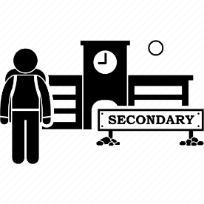
Pupils will be prepared for the transition by:
- Attending transition support provided by the NELFT at our school
- Attending the SEMH project provided by STLS.

17. What support is available for me and my family?
If you have questions about SEND, or are struggling to cope, please get in touch to let us know. We want to support you, your child and your family.
To see what support is available to you locally, have a look at Kent local offer. Kent County Council, publishes information about the local offer on their website:
https://www.kent.gov.uk/education-and-children/special-educational-needs#local-offer
Our local special educational needs and disabilities information advice and support services (SENDIASS) organisations are:
https://councilfordisabledchildren.org.uk/what-we-do-0/networks/iassn/find-your-local-ias-service/south-east/kent

Local charities that offer information and support to families of pupils with SEND are:
The School Health Service - The School Health Service in Tonbridge and Malling can offer a range of support, including self-referral for counselling for young people. There are lots of links to local services too.
Early Help - Early Help (support from families) in Kent offer help for the most vulnerable children, young people and families with a focus on delivering better outcomes.
NHS - Information about the 5 steps to mental wellbeing and strategies about how to achieve them.
NSPCC - Help and advice for parents supporting children with mental health problems.
Young Minds - Young Minds have information, resources and a helpline for parents: 0808 802 5544.
Mind Ed - Excellent information, advice and contacts for all areas of children’s mental health.
Anna Freud Centre - Offers a range of resources that include free podcasts to help parents/carers manage child and family mental health issues.
Every Mind Matters - Support and guidance from the NHS on things like low mood, anxiety, sleep and stress.
Moodspark - A child or young person can build their own emotional resilience by using the resources at Moodsparks, a site built with young people from Kent.
The following contacts may also be helpful for parents and pupils:
- Childline - where children can get in touch on 0800 1111
- In an emergency or crisis pupils should also know they can contact the Samaritans or call 999.
National charities that offer information and support to families of pupils with SEND are:
- IPSEA
- SEND family support
- NSPCC
- Family Action
- Special Needs Jungle

18. What should I do if I have a complaint about my child’s SEND support?

The normal arrangements for the treatment of complaints at The Discovery School are used for complaints about provision made for special educational needs. Click here for more details about our Complaints Policy.
We encourage parents to discuss their concerns with the child’s class teacher and SENCo in the first incidence. If the parental concerns have not be resolved by the class teacher, parents can contact the SENCo, who will meet with the parents to hear their concerns and, where appropriate, will investigate further. Once parents have exhausted the informal complaints procedure, they can make a formal complaint in line with the School's Complaint Policy and Procedure. If the complaint is not resolved after it has been considered by the Governing Body, then a disagreement resolution service or mediation service can be contracted. If it remains unresolved after this, the complainant can appeal to the First–tier Tribunal (Special Educational Needs and Disability), if the case refers to disability discrimination, or to the Secretary of State for all other cases.
To see a full explanation of suitable avenues for complaint, see pages 246 and 247 of the SEND Code of Practice.
If you feel that our school discriminated against your child because of their SEND, you have the right to make a discrimination claim to the first-tier SEND tribunal. To find out how to make such a claim, you should visit: https://www.gov.uk/complain-about-school/disability-discrimination
You can make a claim about alleged discrimination regarding:
- Admission
- Exclusion
- Provision of education and associated services
- Making reasonable adjustments, including the provision of auxiliary aids and services

Before going to a SEND tribunal, you can go through processes called disagreement resolution or mediation, where you try to resolve your disagreement before it reaches the tribunal. Insert contact details of the disagreement resolution and mediation services for Kent.

19. Supporting documents

- Equality Information and Objectives Policy
- Child protection and safeguarding policy
- Behaviour Policy
- Accessibility Plan
- Attendance and punctuality policy
- SEND policy

- SEN & Disabilities Code Of Practice 2015
- Mainstream Core Standards

20. Glossary
- Access arrangements – special arrangements to allow pupils with SEND to access assessments or exams
- Annual review – an annual meeting to review the provision in a pupil’s EHC plan
- Area of need – the 4 areas of need describe different types of needs a pupil with SEND can have. The 4 areas are communication and interaction; cognition and learning; physical and/or sensory; and social, emotional and mental health needs.
- CAMHS – child and adolescent mental health services
- Differentiation – when teachers adapt how they teach in response to a pupil’s needs
- EHC needs assessment – the needs assessment is the first step on the way to securing an EHC plan. The local authority will do an assessment to decide whether a child needs an EHC plan.
- EHC plan – an education, health and care plan is a legally-binding document that sets out a child’s needs and the provision that will be put in place to meet their needs.
- First-tier tribunal/SEND tribunal – a court where you can appeal against the local authority’s decisions about EHC needs assessments or plans and against discrimination by a school or local authority due to SEND
- Graduated approach – an approach to providing SEND support in which the school provides support in successive cycles of assessing the pupil’s needs, planning the provision, implementing the plan, and reviewing the impact of the action on the pupil
- Intervention – a short-term, targeted approach to teaching a pupil with a specific outcome in mind
- Local offer – information provided by the local authority which explains what services and support are on offer for pupils with SEND in the local area
- Outcome – target for improvement for pupils with SEND. These targets don't necessarily have to be related to academic attainment
- Reasonable adjustments – changes that the school must make to remove or reduce any disadvantages caused by a child’s disability
- SENCO – the special educational needs co-ordinator
- SEN – special educational needs
- SEND – special educational needs and disabilities
- SEND Code of Practice – the statutory guidance that schools must follow to support pupils with SEND
- SEND information report – a report that schools must publish on their website, that explains how the school supports pupils with SEND
- SEND support – special educational provision which meets the needs of pupils with SEND
- Transition – when a pupil moves between years, phases, schools or institutions or life stages

