Plan, Learn, Review Grid (Week 3 18^{th-22nd} January)
Plan, Learn, Review is child-initiated time, and the children get to choose what they want to learn. Therefore, your child can choose to play with their toys or try one of the suggested activities. There is no pressure to complete any of these. If you have ideas of your own please feel free to do this instead. These ideas are linked to our remaining curriculum.
Communication and Language  - Can you set up a small world farm if you have one or any small world and act out a story? Make sure you have a character, setting, problem, solution.  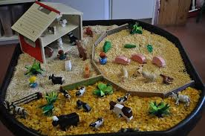  - Make your own telephone and speak to someone through it!  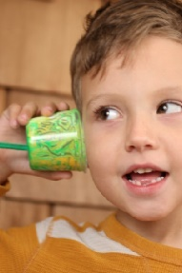 | Personal, Social and Emotional Development  - How do you think the three little pigs might feel at different stages of the story?  Tell your grown up or draw the pigs faces.  1: How do they feel when they leave home?  2: how do they feel when the pig knocks on the door?  3: How do they feel when their house is destroyed?  4 How do they feel when the wolf leaves?  - Can you make a poster about how the big bad wolf could be good? Can you write 5 things he can do to be kind. For example, “share” “say kind things to people” “never hurt anyone”. Can you think of something kind you have done? | Physical Development  - Fill an empty water bottle with cotton wool.  Can use your fingers?  Can you use tweezers?  Can you time yourself?  What is your quickest time?  - Make an obstacle course in the garden or front room. See if you can balance, crawl, hop, jump, climb, slither and slide.  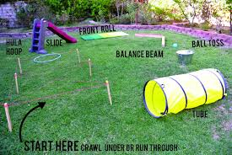
Expressive Art and Design  - Can you make a picture of the three little pigs or their houses?  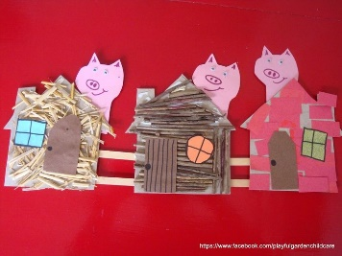  - Can you make a house out of junk modelling?  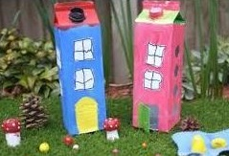 | Understanding The World  - Can you use a range of materials to build a house for one of the pigs (see the ideas below.) Pretend to be a big bad wolf using a hair dryer! See which ones blow down and which ones don’t.  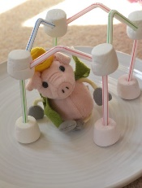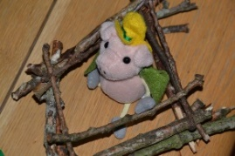  What was the strongest material? Which one was the weakest?  - Can you learn all about pigs? See if you can find out 3 facts! Maybe you can make a fact book. | Literacy  - Can you retell the story, ‘The Three Little Pigs’? Call a family member to show them.  - Can you watch the story of ‘The Three Little Pigs’ on YouTube? What’s your favourite part and why? Can you draw the characters, settings, problem and solution?  - Do your daily reading on Bug Club.
Maths

- Use your number cards and see if you can build a tower to match the value of numbers. Which tower is the tallest? Which tower is the shortest?

- Can you use towers to learn how to add numbers together? For example 1 tower has 3 bricks and another had 5, how many do we have if we put the altogether? 3+5=8!

