Plan, Learn, Review Grid (Week 3 1st-5th Feb)
Plan, Learn, Review is child-initiated time, and the children get to choose what they want to learn. Therefore, your child can choose to play with their toys or try one of the suggested activities. There is no pressure to complete any of these. If you have ideas of your own please feel free to do this instead. These ideas are linked to our remaining curriculum.
Communication and Language  - Can you set up a small world farm with cereals like Weetabix? Can you tell a story using it? Can you film the story using a piece of technology?  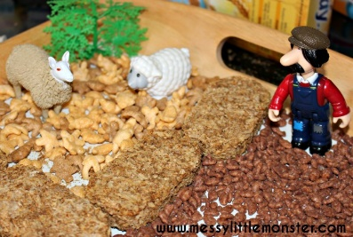  - Can you listen to a fairy tale on YouTube which is not animated? Can you tell someone what happened from listening to it? What was your favourite part?  - DRESS UP DAY FRIDAY 5TH FEB. Can you talk about your character? Can you pretend to be your character, can you act out a story? Can you video call a friend and tell them who you are dressed up as! | Personal, Social and Emotional Development  - Can you make a feelings book and on each page have a different emotion and draw pictures or write about what makes you feel that way? Maybe you can do it using colours like the colour monster!  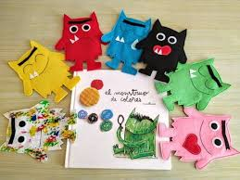  - Can you learn about a different country? Can you find out about their culture? How is it similar to us? How is it different?  - Can you watch the hexagonal breathing on YouTube? Does it make you feel calm? What other things make you feel calm? | Physical Development  - Complete our ‘Get Fit Bingo’ card and win a certificate!  - Can you do the three little pigs cosmic yoga on YouTube?
Expressive Art and Design  - Can you make an outline of a house and paint it with sponges?  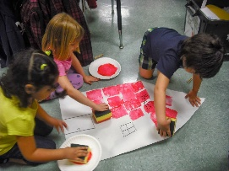  - Can you build a house using sugar cubes?  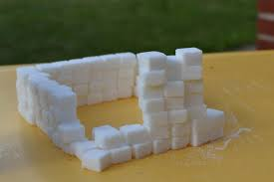 | Understanding The World  - Can you make a diary about the weather each day?  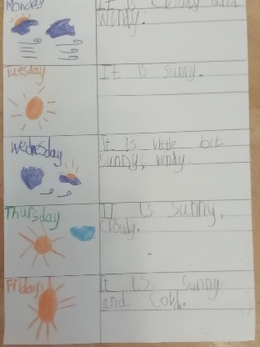  - Can you use the hair dryer to see which materials around your house would blow away or which ones won’t blow away?  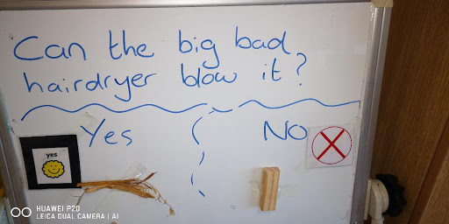 | Literacy  - Do your daily reading on Bug Club.  - Can you find alternative versions of the three little pigs? See if you can listen to them on YouTube.  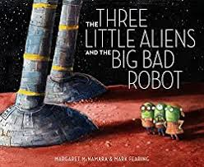  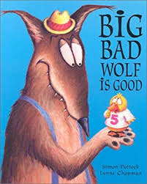  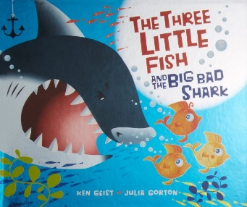  - Can you make a book using a story you have made up or your favourite story?
Maths

- Can you use a dice to roll and build a tower? How tall can you make it until it falls over?
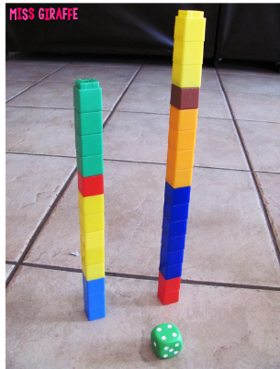

- Can you make a board game using pigs and a wolf? You could draw a game board and if you land on the wolf you have to be blown back 2 places. You could have the three little pigs as characters and the first person to make it to the brick house wins!

