Hist

**French**

Rigolo Unit 9 – Ma journee

Ask and talk about daily routines, times of daily routines and details of a typical day.

**Art and Design –** Media study

**How can we represent a mountain landscape using chalk pastels?**

Develop techniques associated with the use of chalk pastel (e.g. blending, smudging and layering) Develop understanding of effective composition, scale and proportion.

**PSHE**

**How can we keep ourselves safe online and be responsible digital citizens?**

Respect other people’s points of view and constructively challenge those they disagree with.

**English**

Key Texts: ‘Survivors’ – David Long, 'King of the Cloud Forests' - Michael Morpurgo. Non-fiction information texts about Earthquakes and Volcanoes.

Writing genres: Explanations/ narrative/ non-chronological report

SPaG and reading comprehension skills taught through key texts.

**How powerful is the earth?**

**History**

**How can we use sources of factual evidence to learn about historical natural disasters?**

Describe similarities and differences between events and objects studied.

Describe how some changes affect life today.

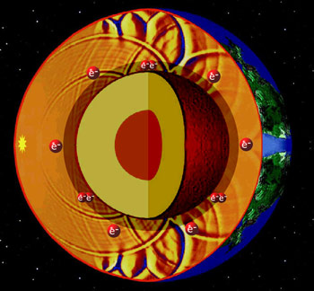

**PE**

Indoor: **How can we use yoga to develop flexibility, strength, technique, control and balance?**

To use yoga skills to improve our physical and emotional wellbeing.

Outdoor: **How can we develop our invasion game skills?**

Netball, benchball, hockey.

**Science –** Animals Including Humans **How does our body work?** To identify and name the main parts of the circulatory system.To recognise the impact of diet, exercise and drugs on our bodies.To describe the ways in which nutrients and water are transported.

**Evolution and Inheritance** To be able to recognise that living things have changed over time and that fossils provide informationabout living things that inhabited Earth millions ofyears ago. To be able to identify how animals are adapted to suit their environment.

**different wand that adaptation may lead to evolution.**

**RE**

**What can be done to reduce racism?**

What is racism and why is it unfair?

What can religion teach us about tackling racism?

How can I express my own vision for justice and equality?

**Is it better to express your religion in arts and**

**architecture or in charity and generosity?**

Describe and make connections between examples of religious creativity.

Show understanding of the value of sacred

buildings and art.

**Music**

**How can we improvise and compose music for different purposes, selecting sounds and structures to convey an idea?**

How can we create music with multiple sections that includes repetition and contrast?

**Geography**

**How can we describe and understand aspects of physical geography?**

**Such as:**

* Volcanoes and earthquakes
* Plate tectonics
* The ring of fire
* Rivers
* Mountains

Locate physical features using maps and atlases.