

**Term 2**

Welcome back everyone; we hope you had a lovely week off.

This term is a very exciting and busy term as we will be learning all about **‘Special People and Celebrations’**

Through this topic we will learn about **Halloween, Bonfire Night, Remembrance Day, Diwali and Christmas**. The children will also be very busy learning The Nativity. The first week back we will have lots of exciting learning opportunities about Halloween and Bonfire Night. Week 2 we will be learning about Remembrance Day. Week 3 we will learn about the Hindu celebration of Diwali and for the rest of the term we will be learning about Christmas and seasonal changes.

**The Nativity**

We can’t wait for you to watch the show and we feel very grateful that we have the opportunity to still perform it this year. Please may we ask for a **payment of £5 via school comms** for you to download the film; once the film is ready you will receive a link to download. Thank you for your support, the children are so excited about the performance. Please do not forget to bring in your child’s costume, if you need any support with this please ask your class teacher.

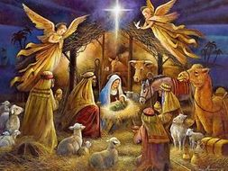

**EYFS Newsletter**

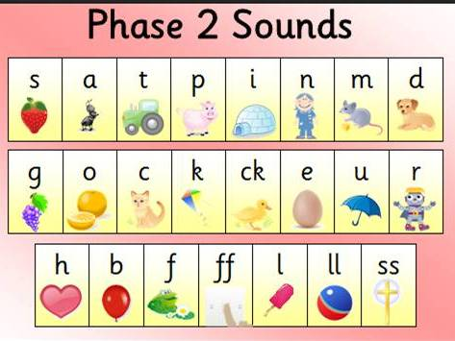our

Maths

In Maths the children will be focusing on a number a day and understanding the value, think about where it can be seen in the environment and how to write the numeral. The children will also be learning to recognise 2D shapes in the environment and learn to use accurate language linked to measures through cooking, building or messy play.

**Phonics**

In Phonics this term the children will be focussing on learning **Phase 2 letter sounds** and use these sounds to begin blending and making or reading words. The children will be making words with the magnetic letters and practising writing using the correct letter formation. They will have a go at writing initial sounds for words. They will also continue to practise writing their names.

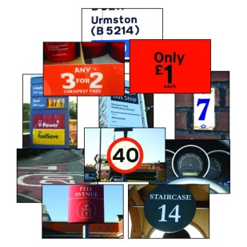



**Key dates to remember…**

* 5th Novemeber Firework Dance Fundraiser: children to wear their own clothes to dance in.
* Wednesdays: PE DAY: please wear PE kit.
* 27th November: INSET DAY

**Reminders…**

* Pleasure check that your child is wearing the **correct school uniform**, the school uniform policy is on our website. The children need to be wearing shirts not polo shirts.
* If you are providing a snack for your child please remember only **FRUIT OR VEGETABLES** are allowed.
* Please remember to bring in your child’s costume for The Nativity, otherwise we cannot film the performance.
* Please NAME all your children’s items of clothing, including ties otherwise they will go missing.
* Please rememeber to log into your **BUG CLUB** account to see what books your teacher has allocated your child.
* If your child makes any achivements at home please remember to fill in a Home Achivements Discovery Apple so we can celebrate it in our Class Celebration Assemblies on Fridays.

**Well Done!**

We have been very impressed with how hard the children have been working with their reading at home and we can see how proud they are of their own achievements.