Friday 3rd September

WELCOME BACK!
Dear Parents and Carers,
We are very excited about welcoming the children back to school next week – especially as we move back to ‘normality’ for the children.
We would like to thank everyone for your support in adapting to the many organisational changes during the last two academic years. We can now look forward to a more normal routine for the children. We are aware that you may have some questions about the start of the school term, so attached to this letter is a Frequently Asked Questions (FAQ) to assist you.
Finally, we would like to thank our premises team for their incredible hard work in getting our school ready for the children’s return to school next week.
Have a lovely weekend everyone!
Kind regards,
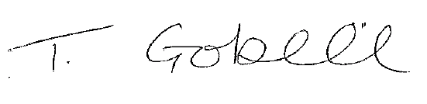

T Gobell
Head Teacher

