Early Years Foundation Stage Framework

Information for Parents and Carers

The Early Years Foundation Stage (EYFS) statutory framework is a government document that all schools and Ofsted-registered early years providers in England must follow. It sets standards for the learning, development and care of your child from birth to 5 years old. The standards ensure your child will learn and develop well and are kept healthy and safe.

**What Is the Early Years Foundation Stage Statutory Framework?**

# What Will My Child Be Learning?

The EYFS framework outlines seven areas of learning and development and educational programmes. There are three **prime** areas of learning, which are particularly important for your child’s development and future learning:

communication and language

personal, social and emotional development

physical development

There are four **specific** areas of learning, through which the prime areas are strengthened and applied:

literacy

mathematics

understanding the world

expressive arts and design

Early years practitioners also use your child’s needs and interests to plan challenging and enjoyable activities and experiences.

# How Will My Child Be Learning?

The EYFS framework identifies the essential role of play in your child’s development. It is through both child-led play and play guided by an adult that your child will develop confidence and relationships with others. Through play, EYFS practitioners will help your child to extend their vocabulary and develop their communication skills.

The EYFS framework identifies three characteristics of effective teaching and learning:

playing and exploring

active learning

creating and thinking critically

A greater focus on teaching specific skills will occur as your child progresses through their reception year, which will help them to prepare for year one.

# How Will I Know How My Child Is Doing?

Each child in the EYFS has a key person who will work in partnership with you, sharing information about your child. EYFS settings may also use observations to share your child’s key achievements.

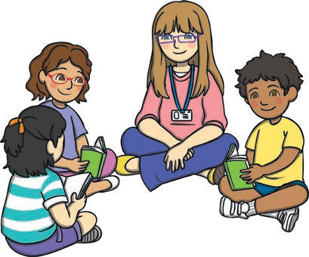

EYFS practitioners use their professional knowledge to understand your child’s level of development. If they have any concerns about your child's progress, they will discuss these with you.

Three formal assessments take place during the EYFS:

* Two-Year Progress Check (this will happen between the ages of 24 to 36 months)
* Reception Baseline Assessment (at the start of the reception year)
* Early Years Foundation Stage Profile (at the end of the EYFS)

Your child’s Early Years Foundation Stage Profile will be shared with you at the end of the EYFS. This will inform you of your child’s progress and whether they have met or are continuing to work towards their early

learning goals (ELGs). There are 17 ELGs your child is expected to achieve by the end of the EYFS.

