3rd September 2025

**MEET THE TEACHER 2025**

Dear Parents and Carers of Years 1- 6,

Welcome back to a new academic year! I hope that you all had a lovely summer break and are ready for the new term.

During the weeks beginning the 8thand 15th September, you are invited to come and meet your child’s new class teacher and the wider year group team. These ‘Meet the teacher’ meetings will give you an overview of the coming year for your child, share with you the expectations for the year group and provide you with ways in which to support your child in their learning. The aim of the sessions is to be informative, and we hope that they will give you the opportunity to learn all you need to know about your child’s new year group.

Sessions for each year group will be held at 9am in the main school hall and will simultaneously be streamed via a link from Microsoft Teams. This link will be sent to you by the school office the night before the meeting.

For those of you who are unable to attend either of these events, a copy of the presentation slides will be available the following day on your child’s year group webpage.

Below are the timings of the ‘Meet the teacher’ events for you. Please queue outside the main hall doors at 8:55am and you will be let into the main hall.

**‘Meet the Teacher’ timings September 2025**

|  |  |  |
| --- | --- | --- |
| Monday 8th September | Year 5 | 9am – 9:30am in the main school hall |
| Tuesday 9th September | Year 4 | 9am – 9:30am in the main school hall |
| Wednesday 10th September | Year 3 | 9am – 9:30am in the main school hall |
| Friday 12th September | Year 1 | 9am – 9:30am in the main school hall |
| Monday 15th September | Year 2 | 9am – 9:30am in the main school hall |
| Tuesday 16th September | Year 6 | 9am – 9:30am in the main school hall |

We look forward to meeting you all over the course of the next two weeks.   
Kind regards,

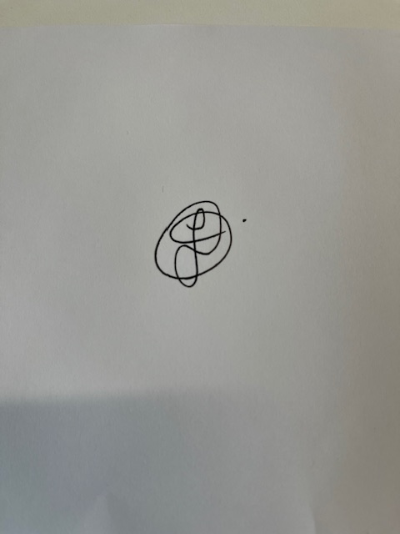

Mrs Oakes

Deputy Head teacher