# The Discovery School



Helping your child at home -

Mark Making and Early Writing

## Overview

Literacy is one of the 7 areas of learning in the Early Years Foundation Stage Curriculum. Literacy is comprised of

Reading and Writing.

This booklet contains a range of advice and ideas to help you to support your child with their Writing (mark making).

By the end of Reception (first year in Primary school) children are expected to be able to:

* Use their phonic knowledge to write words in ways which match their spoken sounds.
* Write some irregular common words.
* Write simple sentences which can be read by themselves and others.
* Spell some words correctly and others will be phonetically plausible.

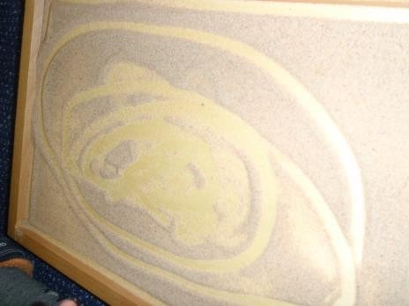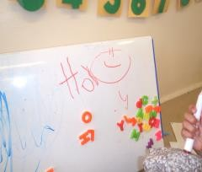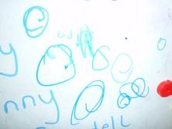

Children will imitate adults, grasping writing tools and making marks on paper. These early attempts need to be nurtured and guided to develop children’s confidence as writers.

Writing should be seen as an enjoyable and fun experience.

Below are the stages that your child may go through as they begin to write. Remember that children develop at their own rates and in their own time.

**Stages of Early Writing**

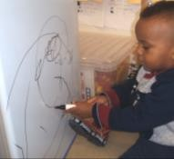Children make random marks (on paper, in sand, spilt liquid) featuring dots, and lines. At this

stage they may not distinguish between writing and drawing—they are making connections between what they see and do and feel. Pencils or other tools may be held in the palm of the

hand in a fist like grip.

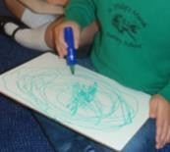

Later they develop different ways to hold tools to get better control. Children often repeat patterns of movement and marks—going over the top of

earlier marks. By making the same marks again and again children develop conscious control that will be used for many tasks in later life—not only writing.

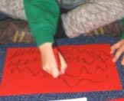Next the child makes marks across the page— often zigzags or wavy lines. They choose to make different kinds of marks and they begin to give meaning to them.

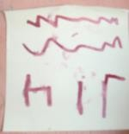

Smaller separate marks begin to emerge

—curves and enclosures— sometimes letters or parts of letters are repeated. Circular marks are naturally made moving anti*-*clockwise with the left hand and

clockwise with the right hand.

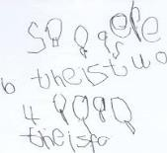The child may move on to begin to use recognisable letters from their own name. As a child develops the control to switch between clockwise and

anticlockwise movements they developing the control required for forming recognisable letters.

Children go through stages in their mark making and in the early stages it is a physical activity. At this stage they may not have a dominant hand and may explore using both hands.

Activities that support your child to develop hand eye co*-* ordination and the physical skill needed to make marks include:

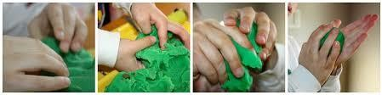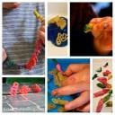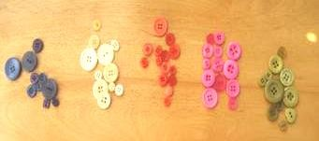

* Playdough/clay and plasticine —

pinching, squeezing, poking, rolling

* Threading—make necklaces with beads, pasta straws
* Picking up small objects—using the thumb and index finger, learning to use tweezers and eye droppers. Sort a variety of small objects including buttons, LEGO, play mobil.

•

* Finger rhymes—stretching and curling fingers e.g. ‘Tommy thumb’, ‘1,2,3,4,5’, ‘two little dicky birds’, ‘Twinkle, twinkle little star’.
* Fix lego, screw and unscrew lids, post pennies in a box and sprinkle seeds.
* Tear and scrunch up paper or foil to make a ball—and learn to flick this with your fingers.

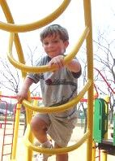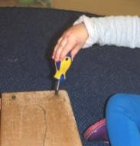

* Using tools—screwdrivers, pliers,

hammers and gardening tools (these can be real or play tools) and sweeping leaves.

* Large physical activities—swinging from a climbing frame, grasping to climb, using the monkey bars and crawling through tunnels.



* Water play—using spray bottles, water pistols and squeezy toys.
* Craft activities—glue sticks and paint brushes, finger painting, making collages, folding paper, cutting and snipping.
* Using a knife and fork to cut food or playdough — using knives to spreading butter to make sandwiches, or to chop vegetables.
* Cooking activities— icing cakes—using a plastic

dispenser to push and squeeze the icing out, and mixing ingredients using both hands (one to hold the bowl and one to stir—stirring clockwise and anticlockwise).

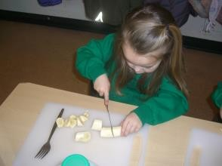

Mark making should go beyond pencil and paper and should include a range of texture and media.

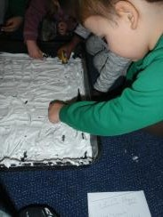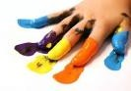Finger painting—making marks with fingers in paint or any liquid.

Make marks in cornflour and shaving foam. Use fingers or a range of different tools.

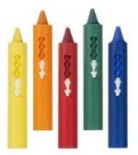Use brushes and chalks/crayons/paint in the bath.

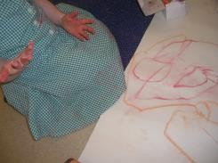Draw on large pieces of paper. Take a line for a walk or a journey—make roads or

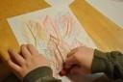paths or places for toys to go.

Make rubbings on a range of surfaces. Holding a crayon like this takes strength and control and can only be done with fingertips.

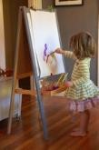

Paint using a vertical easel and large brushes. Join in and experience it yourself. Talk about your own marks. Often children change the meaning of their marks as they work. Try this yourself—”It’s a dragon—now it’s a fire!”

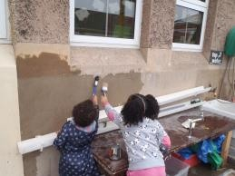

Paint with water outside onto bricks, paving slabs and concrete horizontally and vertically.Vertical mark*-*making on a big scale is great for all children but seems to interest many boys. Are we encouraging graffiti? Wash it off!

C

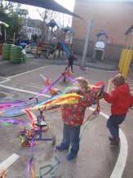

Cleaning is also mark*-*making in reverse— use clockwise, anti*-*clockwise, up & down and side to side movements.

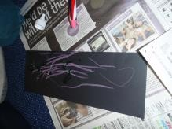Dance with a ribbon or scarf to develop clockwise, anti*-*clockwise, up & down and side to side movements. Talk about the moves you make.

Using chalk on boards or

coloured paper. Short broken chalks are actually good—they cannot be held in the palm and children will use finger tips.

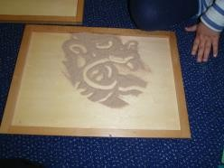

Mark making in sand. Use sticks or fingers. Make marks in mud.

Talk about what you see in the marks—be imaginative and dramatic and join in.

## Things to remember

Make mark making fun, small children have a short attention span. If you can make it fun and exciting for them, it is more likely they will want to participate.

Choose a topic they are interested in.

Little but often is the key, these activities should not last for more than 5*-*10 minutes.

Model writing as much as possible at home and encourage children to use mark making to communicate with other, either through shapes or letters.

The children do not need to start school knowing how to write but to enjoy mark making and exploring new ideas/materials.

